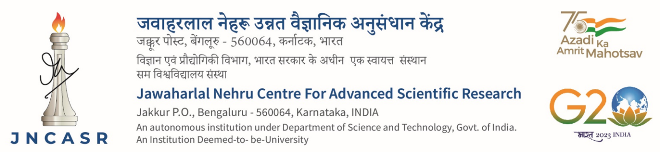

Advt. No. CPMU/EMR/16/22-23 Date: 23.03.2023

Applications are invited for a temporary position of Junior Research Fellow sanctioned in the sponsored project titled “Consortium for collective and engineered phenomena in topology concept” under the Principal Investigator Prof. A. Sundaresan, Chemistry and Physics of Materials Unit, JNCASR, Jakkur, Bengaluru, 560 064.

Sl.No | Position and Eligibility | Max. Age limit | No. of positions
1. | Junior Research Fellow [JRF] (Remuneration Rs.31,000 plus 24% HRA)
 | Essential Qualification: Post Graduate Degree in Physics specializing in condensed matter with a valid score in any one of the National Level examinations.  Desirable Qualification: Strong interest in experimental research on Quantum Materials | 28 years | 01

Interested candidates are required to send a scanned copy of the duly filled in Template (available on the website) along with scan copies of original testimonials in support of educational qualification, age, experience, publication, etc, with a brief resume to Prof. A. Sundaresan, through email sundaresan@jncasr.ac.in latest by 10th April 2023.
Signature of the PI with date

Note:
- Candidates are required to provide their Skype ID, email address and mobile number.
- Shortlisted candidates may be invited for online interview
- No TA/DA will be paid for attending the interview in person.
- Those in employment or pursuing Ph.D, must submit ‘No Objection Certificate’ from the employer/Ph.D. Supervisor.

