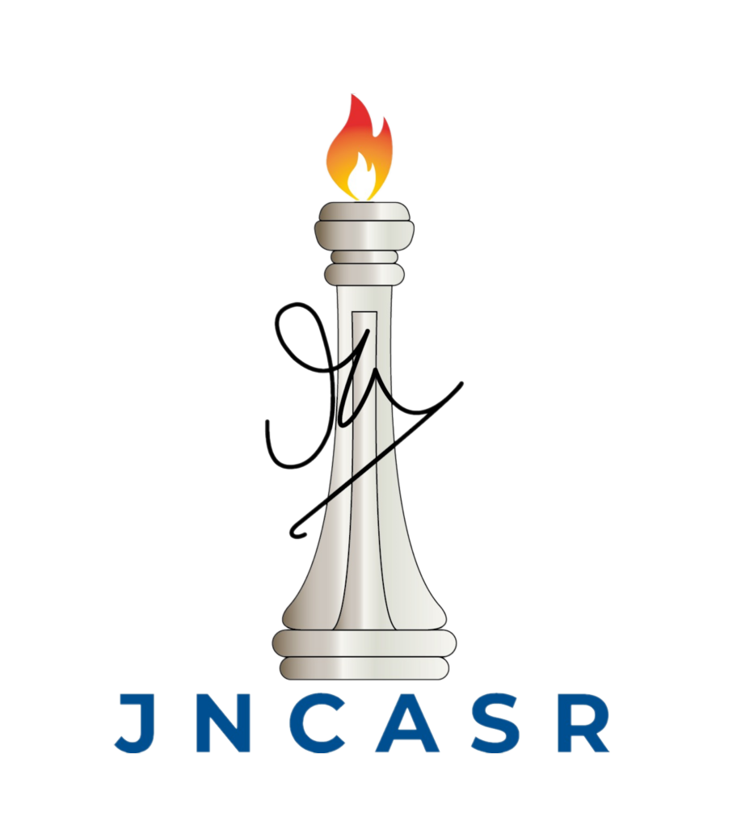Jawaharlal Nehru Centre for Advanced Scientific Research
Jakkur P.O. Bangalore 560 064

Theoretical Sciences Unit TSU SEMINAR NOTICE
Title: “Material Training: Success, Failure, and Improvement through geometrical constraints”
Abstract:
Training materials through periodic drive allows endowing materials to explore the high dimensional space of structures to exhibit desired elastic functions. However, increasing the complexity of the desired response results in ultra-slow convergence of training error and a transition occurs from trainable phase to untrainable phase. Approaching the critical threshold of complexity, low-frequency modes of vibrational properties proliferate and creep down to zero frequency implying that training causes material degradation. We show that the excess low-frequency spectrum is due to atypical local structures. We also show that by imposing geometrical constraints on material structure the degradation can be avoidable, and training can be improved in terms of convergence, capacity, and robustness of training.

Speaker: Dr. Himangsu Bhaumik
Post doctoral fellow, Faculty of Mechanical Engineering Technion - Israel

Date: 09 June 2023 (Friday).
Time: 11:00AM (Tea/Coffee at 10:45 AM) Venue: AMRL Conference Hall, JNCASR

All are cordially invited

