Report on Joint Official Language Sammelan
Held at JNCASR on 22nd & 23rd February 2024
jointly organized by
Department of Science & Technology (DST), Govt. of India,
Jawaharlal Nehru Centre for Advanced Scientific Research (JNCASR),
Indian Institute of Astrophysics (IIA), and
Raman Research Institute (RRI)

Participating Institutions:
- Centre for Nano and Soft Matter Sciences (CeNS)
- Indian Institute of Science (IISc)
- Institute for Stem Cell Science and Regenerative Medicine (inStem)
- National Centre for Biological Sciences (NCBS)

Dignitaries of the conference:
- Ms. A. Dhanalakshmi, Joint Secretary, DST
- Prof. G.U. Kulkarni, Chairperson, Official Language Implementation Committee (OLIC) and President, JNCASR
Invited Speakers:
- Shri Anirban Kumar Viswas, Deputy Director (Implementation), Min. of Home Affairs, Kendriya Sadan, Bengaluru
- Dr. Kamakhya N. Singh, Deputy Director (Official Language), DST, New Delhi
- Dr. S. Mahesh, Asst. Director (Official Language), CAIR (DRDO), Bengaluru
- Smt. Nandita Nidhi, Sr. Translation Officer, DST

About the Conference
During the inspection of the Parliamentary Committee on Official Language and DST on 14th July 2023, a recommendation for organising a Joint Official Language Conference was placed to create awareness among the institutions on the implementation of the official language and help achieve the required milestones towards implementation of OL in the respective institutions. Taking the recommendation forward, OLIC, JNCASR, in association with DST, IIA and RRI, organised this event, which was hosted at JNCASR. 80+ officials joined from the participating institutions.

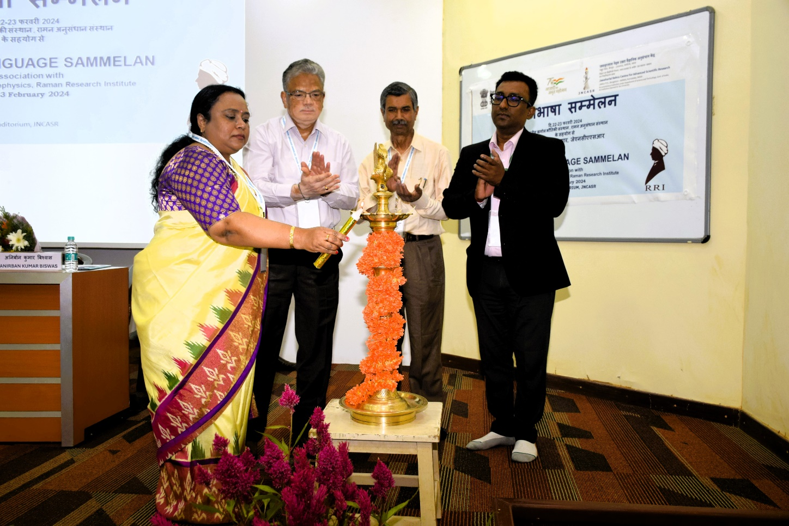
Ms. A. Dhanalakshmi, along with Prof. G.U. Kulkarni, Dr. Kamakhya N. Singh and Shri Anirban Biswas, inaugurated the event with the lighting of the lamp.

The programme of the conference was composed of lectures on topics such as “Rajbhasha and government policy”, “Responsibility of implementation of the Official Language”, “Hands-on training for usage of the latest Hindi software in PCs”, and “Other inspection authorities of OL and our responsibilities”. The speakers shared valuable insights during their lecture and clarified doubts of the participants.

Participants also visited the Chemical Heritage Exposition and ‘A Glorious Journey’ Galleries of the Centre.

On 23rd February 2024 – day 2 of the conference, a science outreach lecture programme in Hindi was also organised which was attended by 80+ students of Jawahar Navodaya Vidyalaya of Bangalore Rural and Urban. Prof. Amitabh Joshi from Evolutionary and Organismal Biology Unit and Dr. Jaishri Sanwal has presented scientific talks in Hindi to the school students.

****

Social Media posts
Post 1:
2-day Official Language Conference began at JNCASR today. The conference was jointly organized by DST, JNCASR, IIA and Raman Research Institute (RRI). 80+ officials attended the Conference from Research Institutions - Centre for Nano and Soft Matter Sciences (CeNS), Indian Institute of Science (IISc), Indian Institute of Astrophysics (IIA), Institute for Stem Cell Science and Regenerative Medicine (inStem), and National Centre for Biological Sciences (NCBS)

Post 2:
Smt. A. Dhanalakshmi, Joint Secretary, DST and Prof. G.U. Kulkarni, President & Chairperson, Official Language Implementation Committee (OLIC), JNCASR inaugurated the conference.

Post 3:
Experts shared valuable insights into the implementation of OL at the workplace.

Post 4:
80+ students from Jawahar Navodaya Vidyalaya students participated in the Science Outreach programme as part of the conference. Prof. A. Joshi & Dr. Jaishri Sanwal presented interesting popular science lectures in Hindi & interacted with the students.

