Gas cylinder Policy

Compressed gas cylinders should be handled only by those familiar with the hazards and who are trained in

**Safe Handling of Compressed Gas cylinders**

•

the proper handling techniques. Cylinders containing compressed gases are heavy and awkward to move.

Improper handling of compressed gas cylinders can result in sprains, strains, falls, bruises, or broken bones.

Other hazards such as fire, explosion, chemical burns, poisoning, and cold burns could occur if gases

accidentally escape from the cylinder due to mishandling.

•

Take the following precautions to prevent injuries caused by the improper handling of compressed gas

cylinders

• Use cylinders as rollers for moving material or other equipment.

• Attempt to catch a falling cylinder.

• Lift a cylinder by its cap using a sling or a magnet.

gases.

Refill compressed gas cylinders. This is to be done only by qualified producers of compressed

• Remove any product labels or shipping hazard labels.

cylinders, valves, or other equipment in oxidizer service.

• Permit oil, grease, or other readily combustible substances to come in contact with

• Tamper with pressure-relief devices.

• Subject cylinders to mechanical shocks that may cause damage to their valves.

• Drop cylinders or permit them to strike each other violently.

Drag or slide cylinders, even for short distances.

•

**NEVER**

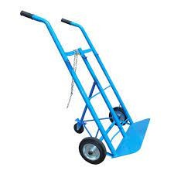

•

bank get out of control or start falling.

Stay out of the bank’s travel path. Also, be aware of escape routes should the

There are two people for localized manual movement of a portable bank.

•

movement on clean, smooth, level stationary surfaces.

Use extreme care and restrict the movement of portable banks to localize

•

shields, leather gloves, safety shoes, and other appropriate equipment.

Use the proper PPE for cylinder handling. Wear safety glasses with side

•

Use a cylinder cage or cradle to lift a cylinder.

replace and secure any valve outlet seals, and properly install the cylinder cap.

When returning cylinders to the supplier, properly close the cylinder valve,

•

Secure cylinders when in storage, transit, or use.

•

has been secured in place and is ready to be used.

Leave the valve protection cap and valve seal outlet in place until the cylinder

•

Move cylinders using a suitable hand truck or cart.

•

ALWAYS

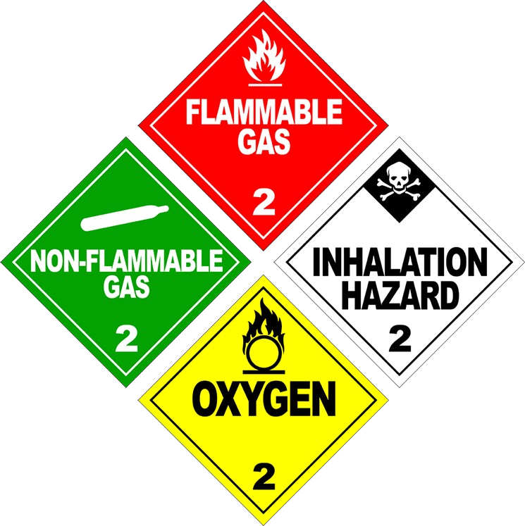

**HANDLING COMPRESSED GASES**

Toxic gases

Flammable gases

Oxidizers

Inert gases

The Major families of gases are:

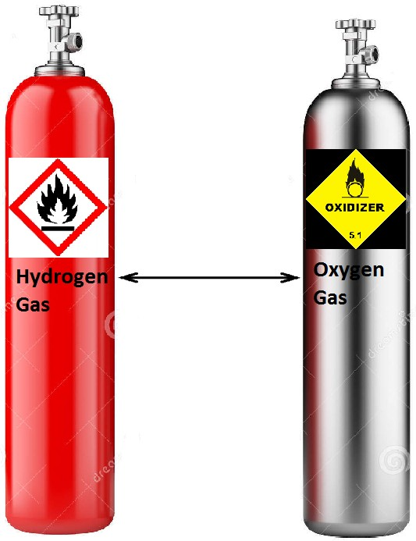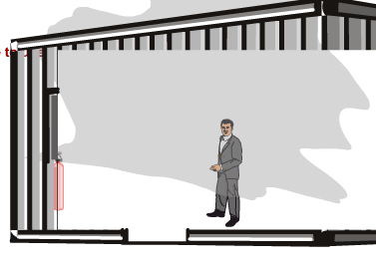

**Oxidizers**

grease

3. Keep away from lubricant,

common oxidizers

2. Oxygen is the most

from flammables gases.

1. Should be stored away

2.They are asphyxiants

smell

1.They cannot be detected by

The main concern are:

**Inert Gases**

**COMPRESSED GAS CYLINDER**

**S AFE WORK PRACTICE FOR**

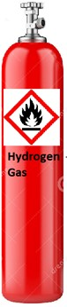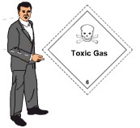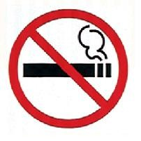

1. Carbon monoxide, hydrogen

**Flammable Gases**

gears/detectors

3. Appropriate safety

2. It can be lethal in small doses

sulfide, ammonia etc.

**Toxic Gases**

sparks, sources of intense heat.

2. Keep away from open flames,

hydrogen and acetylene.

1. Propane, butane, methane ,

**COMPRESSED GAS CYLINDER**

**S AFE WORK PRACTICE FOR**

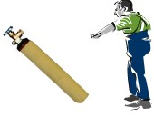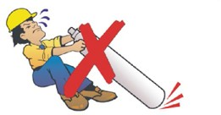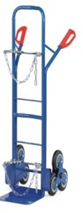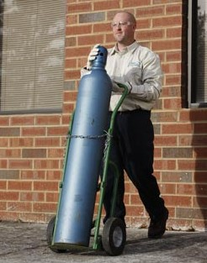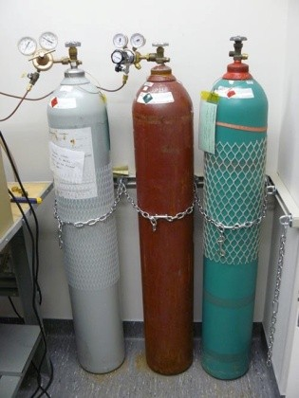

Transport cylinders in trolley.

secure and upright position

Always keep cylinders in a

Never drag or roll the cylinder

**GAS CYLINDER SAFETY**

Don’t drop cylinder