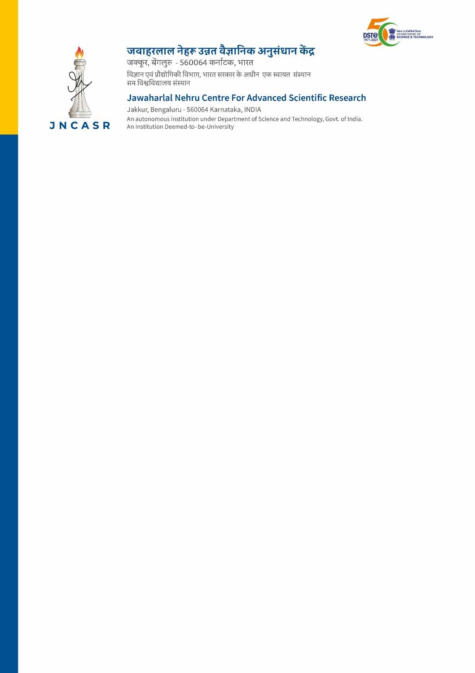

Applications are invited for one position of Project Assistant on purely temporary basis to work under the project “Gender Advancement for Transforming Institutions(GATI)” sponsored by Government of India, Ministry of Science & Technology, Department of Science & Technology (KIRAN Division) under the guidance of Prof. Kavita Jain, Professor, TSU and PI of the project.
Tenure and Job Specification
1 | Tenure of the Project | 18 months
2 | Job Description | Candidate is expected to execute the objectives of the project and should be good with data collection and analysis, report writing, using Microsoft Word, Excel and PowerPoint, along with good communication skills.
3 | Consolidated monthly Salary/Fellowship | Rs. 22,000/- per month
4 | Essential Qualification and experience | M.A. in Humanities & Social Science with 2 years of field experience.
5 | Category | Unreserved
6 | Selection Process | Online written test & interview
7 | Last date of receipt of online application | 15 days from publication of this advertisement
Interested candidates may send their applications to the Principal Investigator, Prof. Kavita Jain through e-mail to gati.jnc@gmail.com. The candidates are required to upload the following documents along with their applications.
1. Detailed biodata 2. Passport size photograph 3. Marksheets and certificates starting from SSLC onwards 4. Experience certificate and any other relevant document.
Shortlisted candidates will be informed through email to take up the written test online, followed by interview through video conferencing. Original documents will be verified online by the Selection Committee.
Note: 1. The softcopy of the documents must be compressed into a zip file (max. file size - 25 MB) before sending them through email as attachment.
2. Those in employment or pursuing Ph.D. should submit a ‘No Objection Certificate’ from the concerned employer/ Ph. D. supervisor.
3. Appointment and payment terms will be strictly as per JNCASR rules and regulations as applicable to project staff, as amended from time to time.

