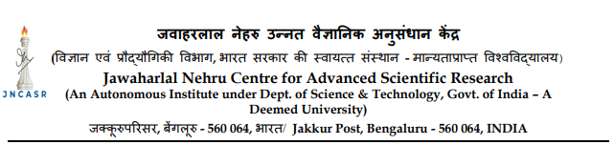
Advt. No.02/NSM/2024-25 Date:29/04/2024

Applications are invited from the eligible candidates for the following administrative positions to be filled on a contract basis to work under the National Supercomputing Mission (NSM) Project, JNCASR: (1) Project Manager, and (2) Office Executive.
- Project Manager - Consolidated Remuneration of up to Rs. 35,000/- p.m. approximately, based on relevant qualifications and experience. Age limit – 35 years

Essential Qualification: A Masters’ degree in relevant field with experience in project coordination of at least 2 years or a bachelor’s degree, along with Microsoft Office specialist certification or equivalent, with 4 years of experience in project coordination. Technical mastery in using office software and web based resources. Good written and oral communication skills are a strong requirement.
Roles & Responsibilities:
All administrative work related to NSM activities, including accounts, documentation and correspondence and reporting to the faculty coordinator. Paperwork and documentation related to projects to be sanctioned under NSM, Coordination with JNC administration in NSM related work, communicating with the Project Investigators, Committees and NSM offices at IISc, CDAC and elsewhere, setting up committee meetings, facilitation work related to scientific workshops and meetings, assistance regarding budget issues of the projects sponsored by NSM, managing procurements and purchases for the project, maintaining and updating information on relevant web pages, managing travel logistics, reporting of project activities to the funding agencies. Etc. Any other work assigned by the superiors from time to time.
- Office Executive (1 post), Consolidated Remuneration of up to Rs.30,000/- p.m. based on relevant qualifications and experience. Age limit – 30 years

Essential Qualification: A bachelor’s degree in Science/Engineering/Commerce/ with relevant experience in project coordination of at least 0-1 year.

- Familiarity with Microsoft Windows and Office products or equivalent. (Familiarity with Word and Excel is a requirement) and handling standard internet and web-based resources. Good communication skills and willingness to work in a team environment. (Good command of English in verbal and written communication a requirement.)

Roles & Responsibilities:
Assisting the project manager in all administrative matters relating to the NSM project including correspondence, project coordination, reporting and documentation, budget and purchase, travel logistics and meeting arrangements. Any other work assigned by the superiors from time to time.

Terms of Appointment: These are contract appointments, initially till Dec 31, 2024, renewable thereafter based on performance and other conditions. Clarifications will be provided to selected candidates.
Interested candidates are required to send a scanned copy of the duly filled in Template (available on the website) along with scan copies of original testimonials in support of educational qualification, age, experience, etc. with a brief resume to NSM Project through email: nsmadmin@jncasr.ac.in latest by 23, May 2024.

Note:

- Shortlisted candidates may be invited for in person interview.
- No TA/DA will be paid for attending the interview in person.
- Online interviews will be considered in special circumstances.
- Candidates are required to provide their Skype ID, email address and mobile number.

