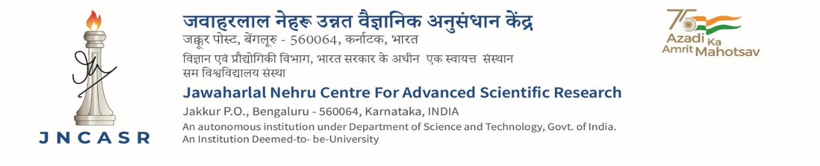
Advt No. JNC/AO/06/2025 Date: 12.11.2025
Rolling Call inviting Expression of Interest (EOI) for Public-Private Partnership (PPP)

JNCASR is keen to develop collaborative research partnerships with industry, NGO, and other
non-government bodies. We invite EoI from interested parties for targeted research for a duration
of five years possibly by supporting a joint faculty under a PPP model. It is expected that such a
joint program will address gaps and problems of national importance.
The focus areas include (i) translation of materials research into technology, (ii) bridging the
bench-to-bedside gap in biomedical research, (iii) semiconductor technology, (iv) Advanced Materials, (v) Renewable Energy & Environment, (vi) Artificial Intelligence and Machine Learning for science and engineering, and (vii) health.
Interested parties may see more details at https://www.jncasr.ac.in/research/translational-research/public-private-partnership and download prescribed format of the EoI and submit in a sealed cover, superscribing “EoI for PPP Proposals,” to the Office of the Dean, Faculty Affairs. Any e-mail queries: dfaoff@jncasr.ac.in
Sd/- Administrative Officer, JNCASR

