

Safety Guidelines

for labs

Practice good housekeeping in all work areas.

Store acids and bases separately. Store oxidizer acids separately. Store fuels and oxidizers separately.

•

Use fireproof cabinets for storage of flammable chemicals.

•

Never smoke, eat, or drink in the laboratory.

•

Do not store food in chemical refrigerators.

•

•

•

Use warning signs to designate hazards.

•

Use appropriate eye protection at all times ,in laboratories and areas where chemicals or biologicals are

transported.

•

Develop a system for the legal, safe and ecologically acceptable disposal of chemical wastes.

Store only minimum amounts of flammable liquids in each laboratory.

•

Provide secure, adequately spaced, well-ventilated storage of chemicals.

•

maximum periods of storage.

. Develop a program for dating stored chemicals and for recertifying or discarding them after predetermined

•

precautions, and the name of the person responsible for the container.

Label all chemicals to show the name of the material, the nature and degree of hazard, the appropriate

•

Maintain a chemical inventory to avoid purchasing unnecessary quantities of chemicals.

•

**General Practice**

**Emergency Plan**

•

Develop plans and participate in drills for dealing with emergencies such as fire, explosion,

poisoning, chemical spill or vapor release, electric shock, bleeding and personal contamination.

•

Display the phone numbers of the fire department, police department, and local ambulance either

on or immediately next to every phone.

•

Ha ve an appropriate supply of first aid equipment on hand and instruction on its proper use

**Protective facilities**

•

Have adequate supplies of personal protective equipment on hand, including safety glasses, goggles,

faceshields, gloves, lab coats, and benchtop shields.

•

Ensure fire extinguishers, safety showers, eyewash fountains, first aid kits, fire blankets and fume hoods are

present in each laboratory and test or check monthly. Activate showers and eyewashes weekly.

•

Ensure guards are on all vacuum pumps and secure all compressed gas cylinders.

•

Remove all electrical connections from inside chemical refrigerators and use magnetic closures. 5. Utilize

grounded plugs on all electrical equipment and install ground fault interrupters (GFI’s) where appropriate

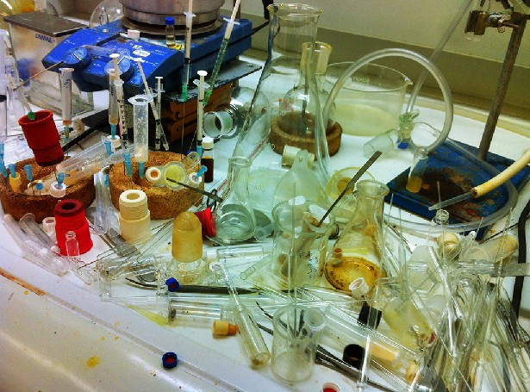

X

1. Keep your workplace tidy

2. Clear up waste, deal with washing up and put things away as you finish with them

3. Make sure everything is safe before you leave things unattended

4. A tidy laboratory reduces the risk of accidents

**SAFE WORK PRACTICES**

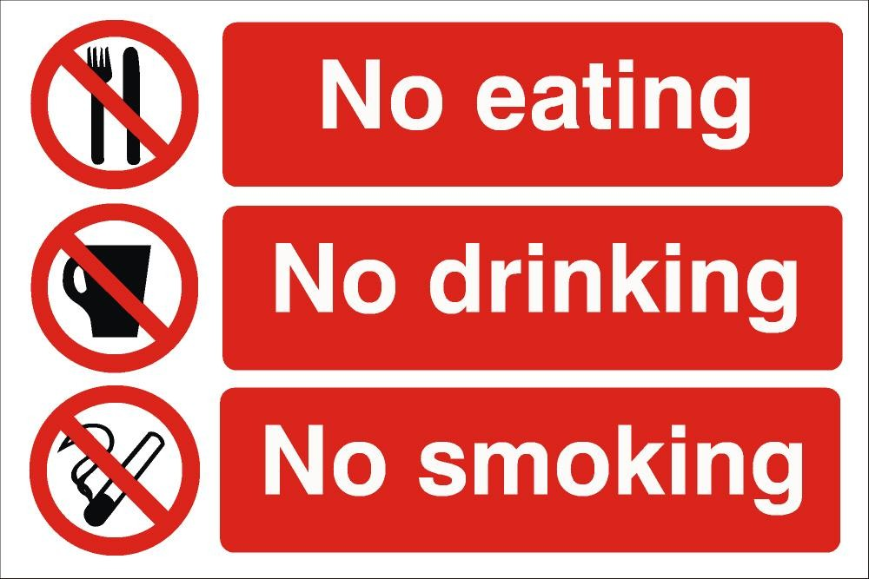

**SAFE WORK PRACTICES**

Never eat, drink, or smoke while

using hazardous chemicals

Use personal protective equipment as required.

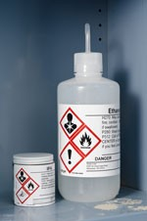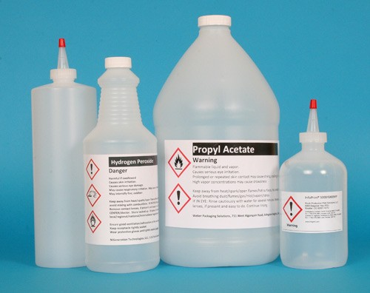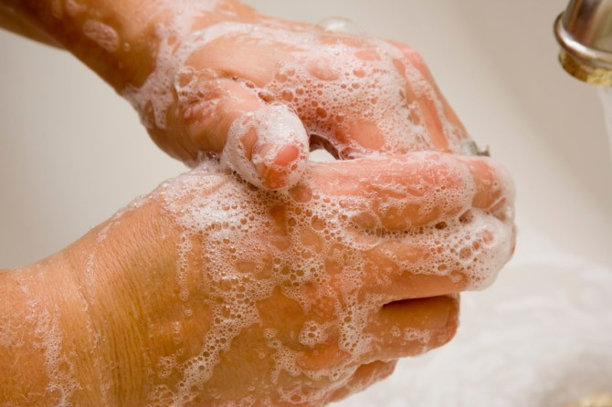

**SAFE WORK PRACTICES**

Make sure all chemical

containers are properly

labeled.

Always wash up after using

chemicals

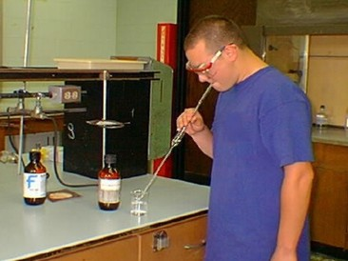

**SAFE WORK PRACTICES**

Do not pipette solutions by mouth

Handle hot glassware with gloves

or beaker tongs. Hot glass looks

the same as cold glass.