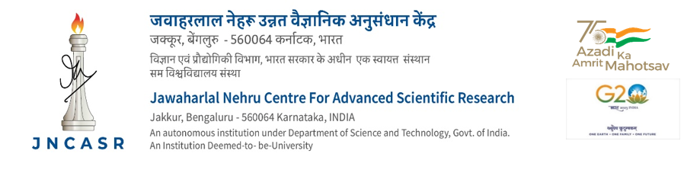

FORM FOR ADMISSION TO CMS

Name : Present Local Address:
Date of Appointment :
Designation :
Basic Pay : Name & Address of the Family Physician
Staff No. :

I request that the medical facilities under CMS may be extended to me and my family*. I am agreeable for deduction of contribution as per rules from my salary and allowances every month.

The particulars of me and my family members for whom medical facilities are required are given below:

Sl. Name Date of Relationship Blood Other Medical facilities Income
No. Birth Group at present availed

I declare that the details furnished above are true to the best of my knowledge and belief.

I also certify that the persons for whom medical facilities are claimed are entirely dependent upon me. I enclose the photos of the beneficiaries.

I also understand that at any point, on verification by authorities to the genuineness of the statements made, proves to be incorrect, appropriate penal action will be taken against me.

Bangalore: Signature :
Date : Name :
Designation:

*(only for permanent staff)
Family: Family for the purpose of the Scheme means employees wife or husband as the case may be and the parents, children wholly dependent upon and normally residing with the employee. Parents will be regarded as wholly dependent on the employee if their total monthly income does not exceed Rs.9000/- p.m.

Unemployed widowed daughters and dependent divorced/separated daughters, wholly dependent on the employee. Unmarried and unemployed sisters, unemployed widowed sisters, unemployed minor brothers and dependent brothers.

Married daughters even though depending on the employee, are not eligible for the medical benefits under this scheme. Such children as are gainfully employed or engaged even on part-time basis in trade, business, profession etc., shall be excluded from the scheme. In the case of adopted children, only legally adopted children will be eligible for medical benefits. Parents will be regarded as wholly dependent on the employee if their total monthly income does not exceed Rs.9000/- p.m. Income Certificate of parents is must for admitting them to CMS.

For the purpose of the income of the parents, lumpsum non-recurring income, e.g., Contributory Provident Fund benefits, Government of India Prize Bonds, Gratuity, Insurance benefits will not be regarded as income. Recurring periodical income from the sources such as houses, land holdings, fixed deposits, etc., will however be taken into account for the purpose of assessing the income.

For Office use only

Admitted to CMS w.e.f. ........................
C.M.S. Card Nos. ........................ issued
Beneficiaries photos are identified

Bangalore Administrative Officer
Date

Received .......... cards

Signature :
Date : Name :
Designation:

