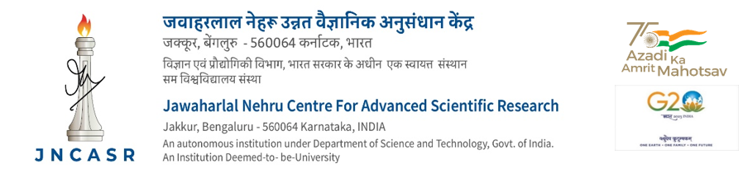

CONTRIBUTORY MEDICAL SCHEME

FORM OF DECLARATION

I hereby declare that the following member(s) of my family who has/have been included under the Contributory Medical Scheme (CMS) of the Centre is/are wholly dependent upon me.

Sl. Name of the CMS Date of Relationship Residential If employed give details -
No. Family Member Regn. Birth Address Name of the Organisation
No. & Income
1

2

3

4

II * I have opted the following doctors as my

Family Physician | Family Gynecologist | Family Pediatrician

*Members who have declared their Family Physician/Gynecologist/Pediatrician, may please furnish the above details.

NOTE :

If the income from all sources including pension and pension equivalent of gratuity of the dependent parents does not exceed Rs.9000/- (Rupees Nine Thousand only) excluding Dearness Relief per month, then they are treated as dependent members upon the prime beneficiary, subject to submission of the Income Certificate from the concerned Revenue Officer/Tahsildar.

Date : Signature :
Name :
Designation :
CMS Regn. No.:

Administrative Officer

