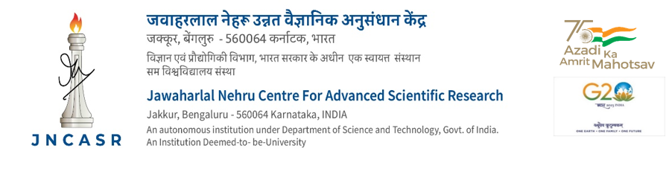

CONTRIBUTORY MEDICAL SCHEME

Application for addition of names of Beneficiaries

Name of the Employee :

Designation and Staff Code :

Pay :

CMS Regn. No. :

Present Residential Address :

Particulars of the Beneficiaries to be included

Sl. Name of the Date of Relationship Blood Occupation, Income,
No. Beneficiaries Birth Group if any if any

I have read the instructions given overleaf carefully and have understood their meaning. I certify that the persons are entirely dependent on me and therefore they are eligible for registration under CMS.

I hereby undertake to declare at the beginning of each calendar year and as soon as necessary thereafter about the eligibility or otherwise to the CMS benefits of the members whose names are mentioned above. I undertake to notify the Centre when any person referred to above becomes ineligible to the CMS benefits, and shall promptly deposit the CMS diaries of such beneficiaries. I realise that the onus of proving eligibility of the members to the benefits of the Scheme rests on me and that giving false information will render me liable for disciplinary action.

I certify that my dependents whose names are mentioned above are mainly dependent on me.

Date: Signature:

* Strike out where not applicable

INSTRUCTIONS FOR THE EMPLOYEE

- Family means: (1) (a) An employee's wife or husband as the case may be; (b) unmarried children and step children (below the age of 25 years); (c) unemployed widowed daughters; (d) parents; (e) sisters (unmarried and unemployed except judicially separated/divorced sisters); (f) unemployed widowed sisters; (g) unemployed minor brothers. [(i) The total number of sisters (both married and widowed) and minor brothers are not to exceed two. (ii) The total number of unmarried children and step children and widowed daughters not to exceed two.] (2) Wholly dependent with the employee.

- If any of the family member/dependents for whom the registration is sought is eligible to receive medical aid/facility, cash subsidy, cash allowances or reimbursement for medical care from sources other than the CMS, particulars of such benefits should be furnished on a separate sheet.

- If any of the members of the family proposed for registration is engaged in trade/business or is employed on part/full time basis, full particulars of such occupation should be furnished on a separate sheet duly supported by documentary evidence so that their eligibility for CMS benefits could be determined.

- The term `Parents' for the purpose of CMS benefits does not include `Step parents'. If the total income of the parents from all sources does not exceed the pay of the employee, subject to the maximum income of the parents being Rs.9000/- per month, such parents may be treated as mainly dependent on the Centre's employee. Income Certificate of parents should be produced to admit without fail. Income from land holdings, houses, fixed deposits, securities, deposits, employment etc., should be taken into account for the purpose of total income of both the parents. The Medical Diaries shall also promptly be deposited with CMS Office if CMS facility is discontinued for any reasons.

- Parents of a married female employee would also be entitled to the benefits of the Scheme if they continue to be wholly dependent on the female employee after her marriage. She will, however, have a choice (the option once exercised can be changed only once during the entire service) to include either her parents or her parents-in-law for availing benefits under the Scheme subject to the conditions of dependence, residence, etc., being satisfied.

- For admitting spouse, wedding card should be produced and birth certificate should be produced in case of new born children.

For Office use only

Registered under CMS with effect from …………….

Administrative Officer

Received ………… CMS Cards/Medical Diaries

Signature of the employee

