**Form No………………………..**

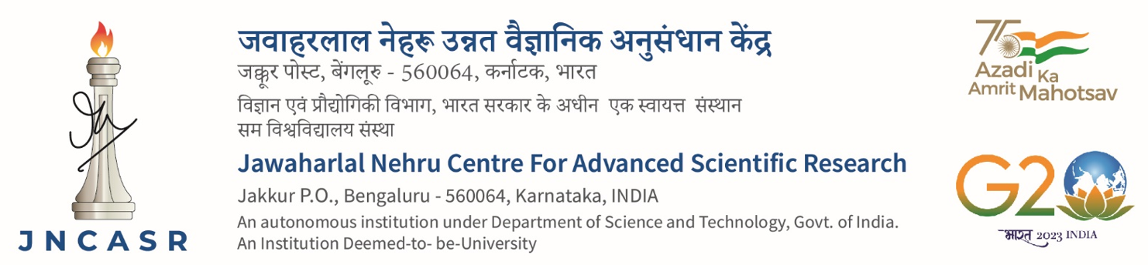**Updated on …………………..**

**EXTRAMURAL RESEARCH PROJECTS**

Request for hiring R&D personnel

1. **Basic information**

|  |  |  |
| --- | --- | --- |
| **Sl. No** | **Description** | **Details** |
| 1 | **Name of the PI** | Prof./Dr./ |
| 2 | **Name of the Co-PI/In-charge**  ( If PI not available) | Prof./Dr./ |
| 3 | **Unit** |  |
| 4 | **Title of the Project** |  |
| 5 | **Source of Funding** | **Government**  **Industry/Private** |
| 6 | **Name of the Funding Agency** |  |
| 7 | **Whether UC/SOE uploaded at the PI’s portal?**  (applicable only in respect of SERB Projects, including newly sanctioned projects) | **Yes**  (If yes, attach the saved pdf of the same)  **No**  (If No, specify the reasons, with justification)  Reasons : |
| 8 | **Debit Head with Code** |  |
| 9 | **Deployment of R&D personnel**  (mention place of work) |  |

|  |  |  |
| --- | --- | --- |
| 10 | **Position to be hired**  (as sanctioned in the project) | **JRF**  **R&D Assistant**  **SRF**  **Research Associate**  **Other  ………………………….**  (please specify) |
| 11 | **Deviations** (in terms of manpower hiring/remuneration) **from the project norms/sanction order** | **Yes**  (If yes, attach the approval for the same)  **Justification**: ………………………………………  (Provide justification for Industry/Private funded projects)  **No** |
| 12 | **Type of appointment\*** | ***Ad hoc(instructions 1 to 8)*** (up to 3 months)  **Normal** (up to 12 months or end of project)  (**Centre’s student** enrolled for degree programme)  **Normal** (up to 12 months or end of project )  (**External candidate** including Centre’s non-degree students) |
| 13 | **Mention the duration of appt.** | **months** |
| 14 | **Name of the Candidate** | **Dr./Mr./Ms** |
| **CV and testimonials of the candidate** | **Enclosed**  [If the type of appointment is Normal (external candidate), the box may be left unchecked] |

**Date:**   **Signature of the PI**

**Note:** Before proceeding further,

* If Centre’s student is being appointed, submit to Academic
* If external candidate, submit to Accounts

***You will receive the file for further processing, within 3 working days*.**

**\*Instructions:**

1. *Ad hoc* appointment is a stopgap arrangement till normal hiring formalities are completed
2. *Ad hoc* appointment is allowed for a maximum period of three months only.
3. *Ad hoc* appointment is operated to meet immediate requirement of R&D personnel
4. *Ad hoc* appointment is also operated when the position falls vacant due to sudden exit of a R&D personnel
5. Any eligible candidate as judged by the PI may be appointed on *Ad hoc* basis.
6. PI should ensure that the testimonials of the candidate considered for *ad hoc* appointment are in order and stand out against the ensuing advertisement
7. *Ad hoc* appointment is made based on the recommendation of the PI only, without following the advertisement procedures
8. *Ad hoc* appointment candidate can either be a **Centre’s student** or an **external candidate**
9. **While processing for a position already filled under *Ad hoc* appointment and subsequently being converted into Normal appointment, a fresh form is to be submitted with updated information, if any.**
10. Normal appointment (Centre’s student) is made based on the recommendation of the PI only, without following the interview procedure.
11. Normal appointment is allowed for a maximum period of twelve months initially, renewable for further period, based on satisfactory performance.
12. **All appointments made through industry/private funded projects preferably go through advertisement procedure. To side-step the advertisement procedure and also, if a candidate is found worthy for payment of higher remuneration, the request should be supported with proper justification.**
13. **For Office use (Academic)**

|  |  |  |
| --- | --- | --- |
| 15 | **Permit appointment of Centre’s degree student as R&D personnel** | **Yes**  **No**  (Tick the **No** box for one of the following reasons):   1. Request for **RA(P) position**, prior to submission of thesis 2. Request for **RA position**, prior to completion of Thesis Defense 3. Request for JRF/SRF position without GATE/NET score 4. Request for partial financial assistance   Other ………………………………………. |
| 16 | 1. **Returned to PI with remarks, if the NO box is checked under 15.**   **PI may modify the request and send it back**    Remarks:  **(b) Sent to Accounts for further processing**  **Academic Coordinator** | |

1. **For Office use (Accounts)**

|  |  |  |
| --- | --- | --- |
| 17 | **Fund availability for the requested position** | **Yes  No**    Rs*……………………………………….*  (If yes, specify the amount in figures) |
| 18 | 1. **Date of commencement/Date of start of project** 2. **Term of the project permits appointment up to the duration requested by PI** | **………………………….. (dd/mm/yyyy)**    **Yes  No**    **……………………………………………**  (If **No**, specify the term of the Project/Project end date) |
| 1. **Status of the UC/SOE** | **Under preparation**  **In transit**  **ACO** |

|  |  |  |
| --- | --- | --- |
| 1. **For Office use (Establishment)** | | |
| 19 | **a) Manpower availability**    **b) Fund position permits appointment up to the duration requested by the PI** | **Yes**  **No**  (Tick the **No** box for one of the following reasons):   1. Request for appointment does not match the sanctioned position.      1. Requested position is already filled 2. The candidate does not possess the requisite educational qualification     Other ……………………………………….  **Yes  No**  **……………………………………………**  (If **No**, specify till what duration the appointment can be permitted) |
| 20 | **Returned to PI with remarks, if the NO box is checked under Sl.Nos.7 and/or 17 and/or 18(b) and/or 19(a), 19(b).**  **PI may modify the request and send it back**  Remarks: | |
| 21 | **If YES box is checked under Sl.Nos.7, 17, 18(b) and 19(a) and 19(b)**  ***Ad hoc*  Normal  Normal**  (**to submit for** (Centre’s student) (External candidate)  **President’s approval (Returned to PI; (Returned to PI**;  **Sl.No.25)**   **PI to proceed to Sl.No.23) PI to proceed to Sl.No.22)**    **AAO(SG)** | |

22**. Advertisement Procedure**

(Please enclose the following documents as per the formats provided)

|  |  |  |
| --- | --- | --- |
| **Sl.**  **No.** | **List of enclosures** | **To be ticked** |
| 1 | **Advertisement copy\*** |  |
| 2 | **Selection process\*\***  (Abstract, Shortlist, Interview, Selection) |  |
| 3 | **List of rejected candidates**  (copies of CVs to be retained at Unit Office for records) |  |

**Note:**

1. **\*Advertisement to be posted on Centre’s Website, giving not less than 7 working days to apply**
2. **\*\*PI may typically shortlist at least 4 candidates for interview, against one position to be filled**
3. **\*\*Two faculty members (one may also be external) apart from the PI, constitute the Selection Committee.**

Date:  **Signature of the PI**

|  |  |  |  |
| --- | --- | --- | --- |
| 23 | **Forwarded by the Unit Chair with remarks, if any**  **Signature** | 24 | **Recommended by Dean, R&D with remarks, if any**  **Signature** |
| 25 | **Approval by the President** | | |