FORM 1
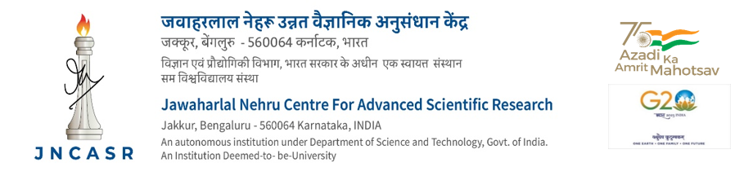

CONTRIBUTORY MEDICAL SCHEME
Application for claiming reimbursement of medical expenses

- Name, Designation
and Staff/Student Code

2. Name of the patient and his / her relationship with the staff member (Claim form should be used for each patient. In the case of children, state age also)
3. CMS Registration No.
- Family Physician / Specialist
  - Name of the Family Physician / Specialist

  - The number and date of consultation
- Hospitalisation / Outpatient
  - Name of the Nursing Home / Hospital / Poly Clinic

  - Period of stay
- Amount claimed
(Enclose Referral form and prescription from Consulting Doctors along with original bills)

DECLARATION TO BE SIGNED BY THE STAFF MEMBER

I hereby declare that the statements made are true to the best of my knowledge and belief and that the person for whom medical expenses were incurred, is wholly dependent upon me.

Date: Signature
Contact No.

Claim verified as per the record of administration. Certified for payment. | Rs ........................(Rupees ..................................
 | ............................................................................
 | .................................................................... only)
 | Head of Account
 | Medical Reimbursement
Asst. Administrator Officer | Asst. Accounts Officer
Date: Date: | Date: Date:

RECEIPT

Received with thanks from Accounts Officer, JNCASR a sum of Rs. ....................................................

..................................................................................................................................... only) by Cash /

Cheque/D.D. in full settlement.

