Form No……
Updated on ………
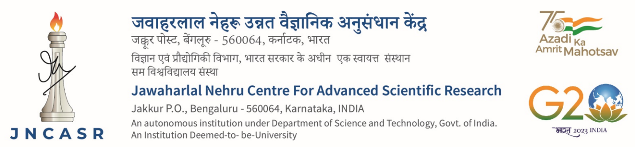

INSTITUTIONAL SUPPORT
Request for hiring R&D personnel
- Basic information

Sl No | Description | Details
1 | Name of the faculty member | Prof./Dr./
2 | Unit
3 | Debit Head | Centre Funds
4 | Deployment of R&D personnel  (mention place of work)
5 | Position to be hired | R&D Assistant  Research Associate(Provisional)  Research Associate  Other ………………………….  (please specify)
6 | Type of appointment* | Ad hoc^{(instructions 1 to 9)} (up to 3 months)  Normal (up to 6 months)  (Centre’s student enrolled for degree programme)  Normal (up to 6 months)  (External candidate/Centre’s non-degree student)
7 | Mention the duration of appt. | months

8 | Name of the candidate | Dr./Mr./Ms
 | CV and testimonials of the candidate | Enclosed  [If type of appointment is Normal (external candidate), the box may be left unchecked]

Date: Signature of the faculty member

Note: Before proceeding further,

- If Centre’s student is being appointed, submit to Academic
- If external candidate, submit to Establishment.

You will receive the file for further processing, within 3 working days.
*Instructions:

- Ad hoc appointment is a stopgap arrangement till normal hiring formalities are completed
- Ad hoc appointment is allowed for a maximum period of three months only.
- Ad hoc appointment is operated to meet immediate requirement of R&D personnel
- Ad hoc appointment can also be operated when the position falls vacant due to sudden exit of a R&D personnel, before completion of the term.
- Any eligible candidate as judged by the faculty member may be appointed on Ad hoc basis.
- Ad hoc appointment candidate can either be a Centre’s student or an external candidate
- Ad hoc appointment is made based on the recommendation of the faculty member only, without following the advertisement procedure
- The faculty member should ensure that the testimonials of the candidates for ad hoc appointment are in order and stand out against the ensuing advertisement.
- Repeated ad hoc appointments for a position is neither allowed with the same individual nor with a different candidate, unless operated under Clause 3 above.
- While processing for a position already filled under Ad hoc appointment and subsequently being converted into Normal appointment, a fresh form is to be submitted with updated information, if any.
- Normal appointment is allowed for a initial period of six months, renewable up to a maximum period of 12 months, based on satisfactory performance.
- Normal appointment (Centre’s student), for the position of RA (P) is allowed for a maximum period of six months or till the date of Viva, whichever event occurs earlier.
- Students whose registration is cancelled will be treated as external candidates.

- For Office use (Academic)

9 | Permit appointment of Centre’s degree student as R&D personnel | Yes  No  (Tick No box for one of the following reasons):  - Request for RA position, prior to completion of Thesis Defense  - Request for higher remuneration without GATE/NET score  - Request for partial financial assistance  Other ……………………………………….
10 | Returned to faculty member with remarks, if under Sl.No.9, the NO box is checked.  Faculty member may re-submit for processing as appropriate.  Remarks:  (b) Sent to Establishment for further processing  Academic Coordinator

C) For Office use (Establishment)
11 | Manpower availability | Yes  No  (Tick the No box for one of the following reasons):  - Requested position is already filled  - The candidate does not possess the requisite educational qualification  Other ……………………………………….
12 | Returned to faculty member with remarks, if under Sl.No.11, the NO box is checked.  Faculty member may re-submit for processing as appropriate.  Remarks:
13 | If the YES box is checked under Sl.No.11  Ad hoc Normal Normal  (to submit for (Centre’s student) (external candidate)  President’s approval; (Returned to faculty member) (Returned to faculty member)  Sl.No.17) (Faculty member to (Faculty member to proceed  proceed to Sl.No.15) to Sl.No.14)  AAO(SG)

14. Advertisement Procedure
(Please enclose the following documents as per the formats provided)

Sl.  No. | List of enclosures | To be ticked
1 | Advertisement copy*
2 | Selection process**  (Abstract, Shortlist, Interview, Selection)
3 | List of rejected candidates  (copies of CVs to be retained at Unit Office for records)
Note:
- *Advertisement to be posted on Centre’s Website, giving not less than 7 working days to apply

- **Faculty member may typically shortlist at least 4 candidates for interview, against one position to be filled

- **Two faculty members (one may also be external) apart from the proposing faculty member, constitute the Selection Committee.

Date : Signature of the faculty member

15 | Forwarded by the Unit Chair with remarks, if any  Signature | 16 | Recommended by Dean, R&D with remarks, if any  Signature
17 | Approval by the President

