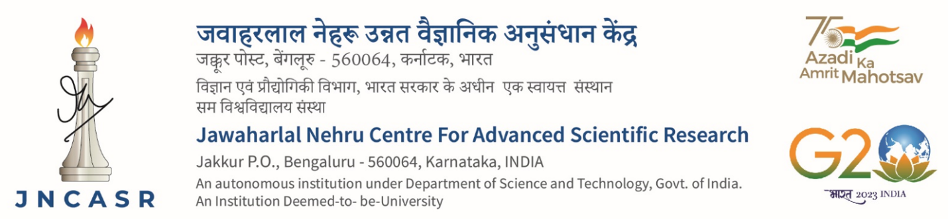

**Advt. No. Date:**

Applications are invited for temporary position of **R&D Assistant/Research Associate** to work under the guidance of Prof./Dr.____________________________, ____________________________Unit, JNCASR, Jakkur, Bengaluru, 560 064.

|  |  |  |  |
| --- | --- | --- | --- |
| Sl.No | Position and Eligibility | Max. Age limit | No. of positions |
| 1. | **R&D Assistant (Remuneration Rs.19,000/- (Without NET/GATE etc), Rs.25,000/- (With NET/GATE etc) and Rs.28,000/- (M.E/M. Tech etc) plus 24% HRA** | | |
| **Essential Qualification**: Post Graduate Degree in Basic Science OR Graduate/Post Graduate Degree in Professional Course  **Desirable Qualification:** | 28 years |  |
| 2. | **Research Associate (Remuneration Rs.47,000/-, Rs.49,000/- and Rs.54,000/- plus 24% HRA). Remuneration will be fixed based on experience** | | |
| **Essential Qualification:** Ph.D/MD/MS/MDS or equivalent degree **OR** three years of research, teaching, design and development after MVSc/M.Pharm/M.E/M.Tech with at least one research paper in Science Citation Index (SCI) Journal.  **Desirable Qualification:** | 35 years |  |

**Interested candidates are required to send scan copy of duly filled in Template (available on website) along with scan copies of original testimonials in support of educational qualification, age, experience, publication, etc with brief resume to Prof./Dr. ____________, _________Unit through email …………….@jncasr.ac.in latest by ……………………………………..**

**Signature of the faculty member with date**

**Note**:

1. Candidates are required to provide their Skype ID, email address and mobile number.
2. Shortlisted candidates may be invited for online interview
3. No TA/DA will be paid for attending the interview in person.
4. Those in employment or pursuing Ph.D, must submit ‘No Objection Certificate’ from the employer/Ph.D. Supervisor.

**Sub: Selection process for the position of ………………………………………**

**through Institutional Support**

**Ref: Advt. No…………………………… dated ………………………….**

|  |  |  |  |  |  |  |
| --- | --- | --- | --- | --- | --- | --- |
| Sl No | Name | Age is within the permissible limit as per Advertisement  *(tick the appropriate column)* | | Shortlisted for interview  *(tick the appropriate column)* | | Remarks |
| Yes | No | Yes | No |
| 1 |  |  |  |  |  |  |
| 2 |  |  |  |  |  |  |
| 3 |  |  |  |  |  |  |
| 4 |  |  |  |  |  |  |

1. **Abstract/shortlist**
2. **Recommendation by the Selection Committee:**

After evaluation of the technical skills, qualification, experience and performance in the interview, the Committee recommends the following candidates:

|  |  |  |
| --- | --- | --- |
| **Particulars** | **Name** | **Application No.** |
| **Selected candidate** |  |  |
| **Waitlist** |  |  |

**Member Member Faculty Member**