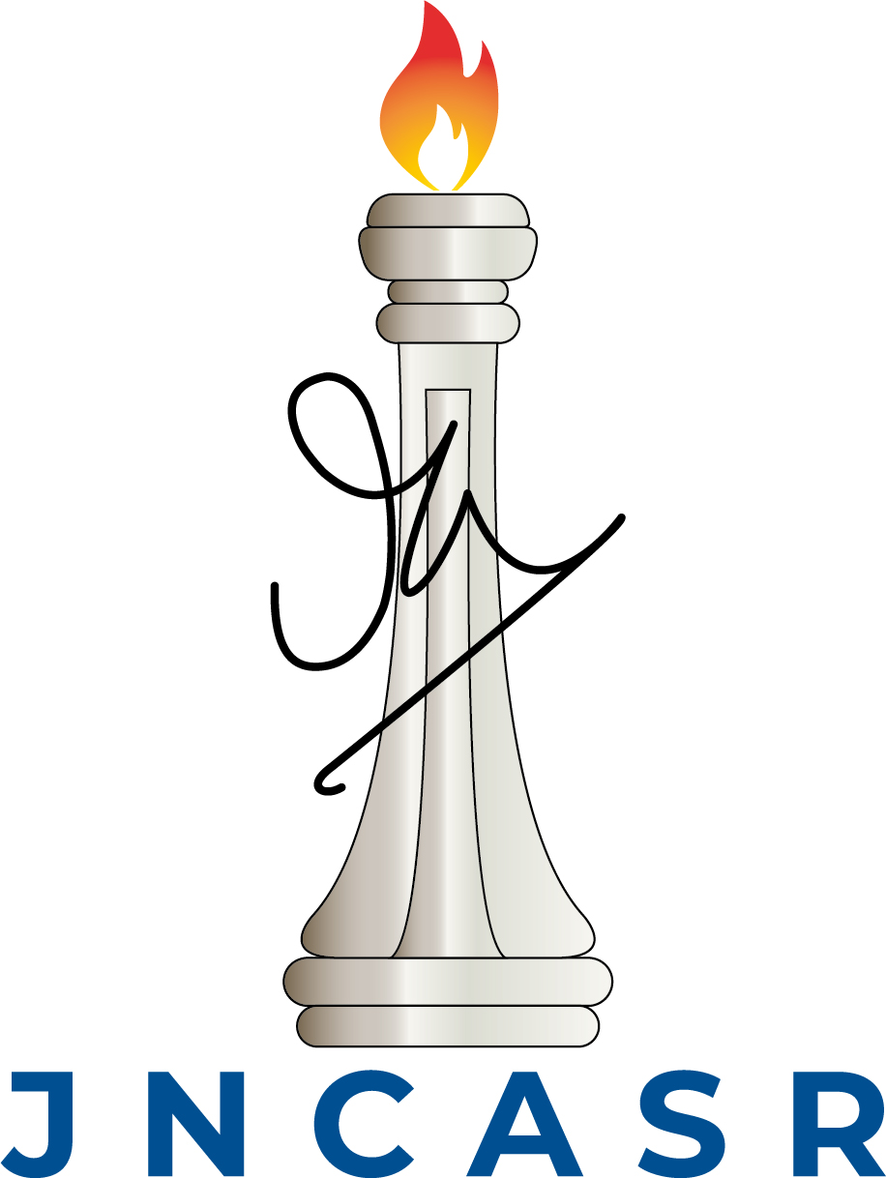
International centre for materials science

Jawaharlal Nehru Centre for Advanced Scientific Research
Jakkur Post, Bangalore 560064, India
I-House
Reservation form

Discussion Meeting / Conference / Symposium / School / Dept. Visitor / Others

Title of the Meeting / Guest Names:

Type of rooms to be reserved
Single Room (Non A/C)
Single Room (A/C)
Double Cot Room (Non A/C)
Double Cot Room (A/C)
Suite room
Number of rooms to be reserved

Reservation from (Date and Time)
Reservation till (Date and Time)
Booked By (Name and contact details)
Budget Head
Signature of the host

Food requirements: YES/NO
Date | Breakfast | Lunch | Dinner | No. of Guests

Approval of the Associate Director, ICMS_______________________

